TITLE:-SWITRA AND MANAGEMENT THROUGH AYURVEDIC TREATMENT AND CUPPING THERAPY W.S.R.TO VITILIGO.

AUTHOR:-Vd.Tejas Shivaji Date(3rd yr PGKayachikitsa),SMBT Ayurved College.

CO AUTHOR:-Vd.Varsharani Niphade(Guide,Associate Professor,Kayachikitsa)

ABSTRACT:-

In Ayurveda, all concept of disease, Dosh, Dushya, Nidan, Chikitsa are very specific and clear. In skin disease, Ayurveda has its own concept of treatment which is very beneficial and results are seems to be wonderful. Skin is a protective layer of the body work as covering. Any impairment of body can reflect over the skin. In Ayurveda Prabha of skin is due to Bhrajak Pitta. All skin disease comes under Kushta Roga and Switra is one of them. Switra is mention in Kushta Roga Chikitsa where white patches appear on the whole body or a local region. In modern medical science it comes under vitiligo .Vitiligo comes under a cosmetic disfigurement of skin and 1% of total world population affected by it. Here is an attempt to establish the concept treatment of Switra trough Ayurveda and cupping therapy.

KEYWORDS:-Switra, Kushta Roga, vitiligo, cupping therapy.

# INTRODUCTION­:-

Several references of Switra are found in Ayurveda text. The word Switra is derived from Sweta in Sanskrit, which means white patch. So Switra is a disease where white patches appear in the whole body. In Ayurveda, skin is a very essential sense organ of the body. Skin covers all over the body as covering, Bhrajak Pitta is placed in skin and responsible for reflection of chhaya of skin. **[1]** Any impairment of Bhrajak Pitta and Vata Dosha can cause skin disease like Switra. Switra is mention in Kushta Roga Chikitsa in Ayurveda classics. **[2]** Just like Kushta It is caused due to Vitiation of Tridosh and Dhatus like, Rasa, Rakta, Mansa and Meda. **[3]** In modern medical science, the characteristics of Switra are similar to vitiligo. Vitiligo is a condition, in which the skin colour turn white due to the loss of melanocytes cells that produce pigment melanin responsible for colour of skin or we can say hypopigmentation of skin. It looks cosmetically ugly. So basic treatment of vitiligo in modern medical science is topical creams contain corticosteroids, some type of radiations, skin grafting and medical tattooing etc. Which is very harmful for skin and the body also? In Ayurveda classics, Ayurvedic treatment for Switra is given by many Acharyas. The results of cupping therapy are also very good.

# AIMS AND OBJECTIVES:-

1. To study the effects of Ayurvedic treatment in Switra
2. To study the effect of cupping therapy in Switra.

# MATERIAL AND METHOD:-

This study was carried out in Charma Roga nivaran unit in Dhanwantari Ayurvedic College.

# CASE REPORT:-

A 39 year old male patient,visited Charma Roga nivaran unit opd in Dhanwantari Ayurvedic medical hospital, on 8 may 2019 presented with whitish discolouration over dorsal region of feet, palm and posterior fold of axilla and mild itching over there since 1 year.

# HISTORY OF PRESENT ILLNESS:-

Patient was healthy before 1year. Gradually he developed some discolouration on his feet, palm and posterior fold of axilla which gradually convert into a whitish patches.

# PERSONAL HISTORY:-

Dietary habits revealed that so much use of Lavana, Amla Dravya, mixed dietary habits, excessive tea intake, curd, oily and spicy food, Viruddha Ahara Vihara, irregular bowel habits. Sleep- disturbed, addiction – no,

# PSYCOLOGICAL HISTORY:-

The patient of Switra will feel that they are separated from the society and get depressed psychologically.

Patient had more stress 3month back due to work and other issues and complained of insomnia. The discolouration of patches increased day by day from 3month.

Past history, drug history, allergic history, family history was not significant.

# GENERAL EXAMINATION:-

# Pallor- present, icterus-absent, cyanosis- absent, clubbing- absent, lymph node- not palpable, Oedema- absent. In feet, palm, axilla whitish discolouration presented with mild itching, BP- 130/80 mm of hg, pulse- 78/min.

# INVESTIGATIONS:-

LAB INVESTIGATION-

Haematological reports reveals Hb%- 13 gm%.

**TREATMENT:-**

Bakuchi tail -50ml mixed with white petroleum jelly for local application Bakuchi ghana vati - 2*bd before meal Swadista virechana churna - 3gm*hs with Luke warm water

Arogyavardhini vati - 2*bd after meal Pigmento ointment - for local application Lucoskin drop -10drop*bd with half cup of water

Cupping therapy – every opd visit at least for 5 times

The patient was advised to take the medicine for 6 month and gradually withdraw the allopathic medicine one by one. He has also avoidance of Lavana, Amla rasa and Tikshna Dravya, curd, spicy food, Pittaja Ahara Vihara, Adhyasan, Divasvapna, Ratrijagaran, stress, anxiety etc.

After 3 month previous symptoms subsides and white patches turn into black.

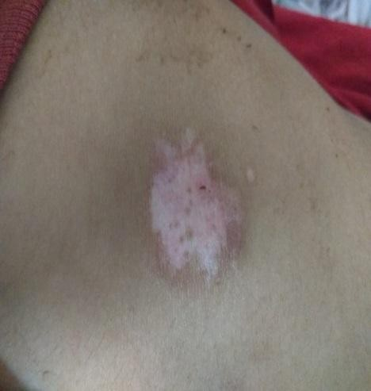 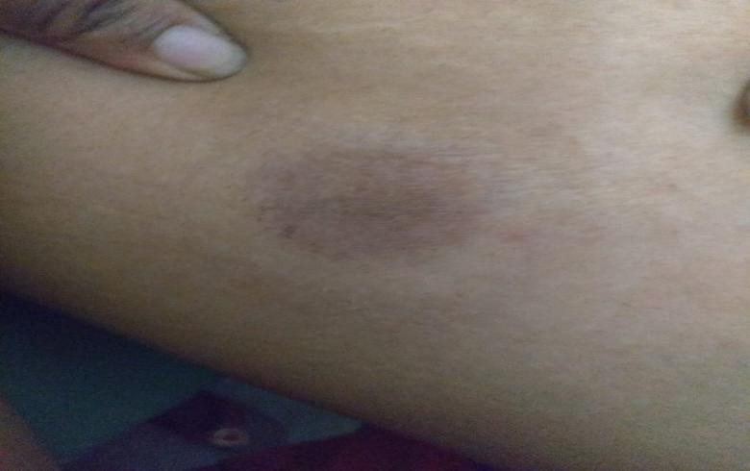

**Figure 1- Before treatment Figure 2- After treatment**

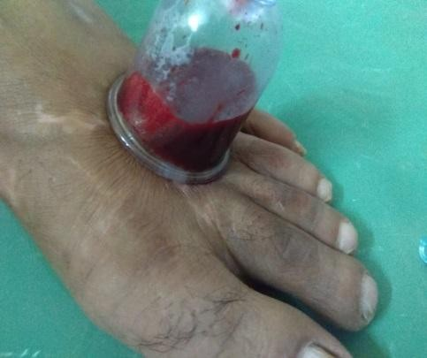 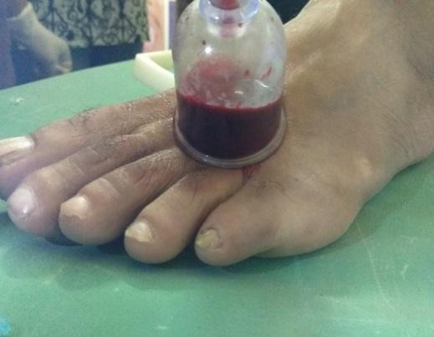 **Figure 3- Cupping therapy** **Figure 4: Cupping therapy**

**DISCUSSION:-**

As per the schedule, patient has taken medication and asked to follow diet by avoiding Lavana, Amla, Tikshna Dravya, curd, spicy food, Divasvapna, Ratrijagaran etc. cupping therapy is done in every opd visit at least for 5 times gape of 1 week. After the follow up there is unbelievable changes seen in patches, white patch on the feet become black and appears as normal, reduction of itching, insomnia controlled, symptoms get reduced.

In the case of Switra, line of treatment is Bhahya and Abhyantar use of Kusthaghna Dravya as per sign and symptoms of patient.

Bakuchi oil has been used traditionally in the treatment of Switra mentioned in Ayurvedic text. **[4]** Bakuchi tail mainly act on skin colour. It has an irritant effect on skin and mucous membrane and powerful effect against bacteria of skin. The patient skin is sensitive for it, so as a precaution we use Bakuchi tail with white petroleum jelly to reduce its irritant effect and advice patient to sit in sunlight for a while.

Bakuchi Ghana vati content Shuddha Bakuchi provide nourishment to the skin cells and help on rejuvenating the cells. It has anti-inflammatory properties and quick healing properties. Bakuchi is known as kusthaghni in Ayurveda text. **[5]**

Swadista virechana churna is used for virechana karma. Virechana karma is indicated in Kushta Vyadhi in every 15 days. Swadista virechana churna has following properties like virechana and detoxification, blood purifier, anti-pruritic, antibacterial, antimicrobial function, also Indicated in skin disease as mild purgative.it content Sanaya for virechana and Suddha Gandhak plays role in skin disease to reduce itching and burning sensation.

Arogyavardhini vati is mentioned in Rasaratnasamucchaya for the treatment of Kushta. **[6]** It act as Dhatu Poshaka. if. If there is any impairment of any Dhatu we can use Arogyavardhini vati. Here 4 Dhatus are involved in switra. It has anti-pruritic property, antioxidant property. It improves digestion and metabolic activities

Pigmento ointment is used for hypopigmentation of skin. It has wound healing properties, anti-inflammatory effects, treating skin infections, showing anti-microbial activities. It also contains, Bakuchi has already very beneficial in Switra as above mentioned, Chakramarda having antibacterial and antimicrobial activity, Suddha Gandhak is local irritant so that it activate the melanocyte for melanin production.

Lukoskin drop- Bakuchi is a traditional drug for vitiligo treatment and it is a chief component of lukoskin drop. It is very effective and helps in restoring the normal complexion in the affected area. It also contains Ammi majus (yavani) which stimulates the melanin synthesis that is exposed to sunlight.

Cupping therapy is used as Raktamokshan therapy. It activate and stimulate the reaction of body system by which brain attention to the injurious part of skin and also stimulates the pituitary gland which is responsible for secretion of melanocyte stimulating hormone responsible for melanin formation. It helps to regulate the normal colour of skin.

# CONCLUSION:-

Skin reflects the beauty of healthy individual. Any impairment can causes cosmetic disfigurement. Colour of skin play very important role in the society. It is important to recognize and deal with the physical and psychological factors of the disease to improve their healthy life and quality of it. In this single case study we trying to give an idea for the line of treatment of Switra through Ayurveda perspective and cupping therapy.

# REFERENCES:-

1. Sushruta. Sushruta Samhita, edited with Ayurveda-Tattva-Sandipika Hindi commentary by Kaviraja Ambhikdutta Shastri, Vol- 1, Chaukhambha Sanskrit Sansthan, Varanasi, Reprint-2014, Chapter no:21, pg.no:115
2. Tripathi Bramhanand edited by Charak Samhita revised by Charak and supplemented by Dridhabala, Chaukhambha Surbharti Publication; vol- 2,Reprint – 2011,Chepter no-7, peg no.331
3. Tripathi Bramhanand edited by Charak Samhita revised by Charak and supplemented by Dridhabala, Chaukhambha Surbharti Publication; vol- 2,Reprint – 2011,Chepter no-7, peg no.333
4. Sushruta. Sushruta Samhita, edited with Ayurveda-Tattva-Sandipika Hindi commentary by Kaviraja Ambhikdutta Shastri, Vol- 1, Chaukhambha Sanskrit Sansthan, Varanasi, Reprint-2014, Chapter no:14, pg.no:52,53
5. Chunekar KC, Pandey GS. Bhavaprakash Nighantu, 1st edition, Choukhambha Bharti Academy; Reprint-1010 p.no. 191-121
6. Ambhikdutta Shastri, Rasaratnasamucchaya, 9th edition, Chaukhambha Sanskrit Publisher, Reprint-1994, chapter- 20 peg. no. 400